**Solutions and Screenshots**



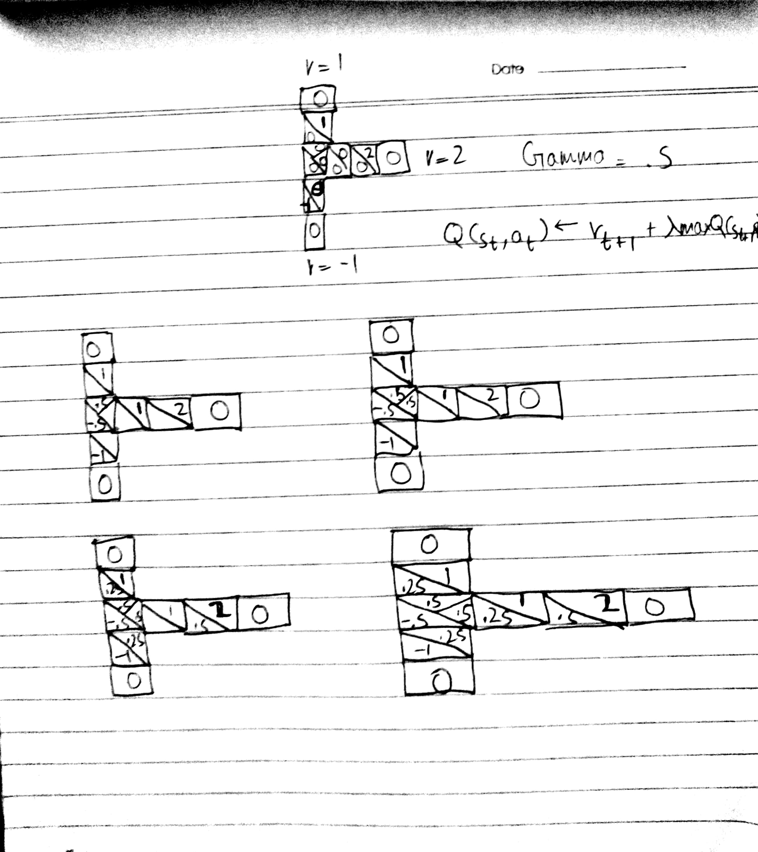

1. In file 2.ipynb. Used GPU version of Tensor flow.

Change **tf.device('/gpu:0')** to **tf.device()** if checking on device without the GPU

**References**

1. [1] "Simple Reinforcement Learning with Tensorflow Part 0: Q-Learning with Tables and Neural Networks", Medium, 2017. [Online]. Available: https://medium.com/emergent-future/simple-reinforcement-learning-with-tensorflow-part-0-q-learning-with-tables-and-neural-networks-d195264329d0. [Accessed: 27- Nov- 2017].